|  |  |
| --- | --- |
| **Name:** | **RAHUL RAMMILAN YADAV** |
| **Roll No:** |  |
| **Class/Sem:**  **Experiment No.:**  **Title:**  **Date of**  **Performance:**  **Date of Submission:** | DSE/III  10  Program to implement Simple Animation |
|  |
| **Marks:** |  |
| **Sign of Faculty:** |  |

**Experiment No. 10**

Aim :Program to implement Simple Animation (Perform Animation (such as Rising Sun, Moving Vehicle, Smileys, Screen saver etc.) in C

Objective :

To perform a simple animation using graphics.h header file

**settextstyle settextstyle function in c**

Settextstyle function is used to change the way in which text appears, using it we can modify the size of text, change direction of text and change the font oftext.

Declaration :- void settextstyle( int font, int direction, int charsize); font argument specifies the font of text, Direction can be HORIZ_DIR(Left to right) or VERT_DIR (Bottom to top).

**1.Different fonts** enum font_names { DEFAULT_FONT, TRIPLEX_FONT, SMALL_FONT,

SANS_SERIF_FONT, GOTHIC_FONT, SCRIPT_FONT,

SIMPLEX_FONT, TRIPLEX_SCR_FONT, COMPLEX_FONT, EUROPEAN_FONT, BOLD_FONT

};

**outtextxy**

outtextxy function display text or string at a specified point(x,y) on the screen.

Declaration :- void outtextxy(int x, int y, char *string);

x, y are coordinates of the point and third argument contains the address of string to be displayed.

Code :

#include <graphics.h>

#include <stdlib.h>

#include <stdio.h>

#include <conio.h>

void drawCar(int x, int y) {

    rectangle(x, y, x + 150, y + 50);

    rectangle(x + 10, y + 10, x + 30, y + 40);

    rectangle(x + 120, y + 10, x + 140, y + 40);

    line(x + 10, y + 10, x + 30, y + 10);

    line(x + 30, y + 10, x + 40, y);

    line(x + 40, y, x + 110, y);

    line(x + 110, y, x + 120, y + 10);

    line(x + 120, y + 10, x + 140, y + 10);

    line(x, y + 50, x + 150, y + 50);

}

int main() {

    int gd = DETECT, gm;

    initgraph(&gd, &gm, "C:\\Turboc3\\BGI");

    int x = 0, y = 200;

    for (int i = 0; i <= getmaxx() - 150; i += 5) {

        cleardevice();

        drawCar(x + i, y);

        delay(50);

    }

    getch();

    closegraph();

    return 0;

}

**Output:**

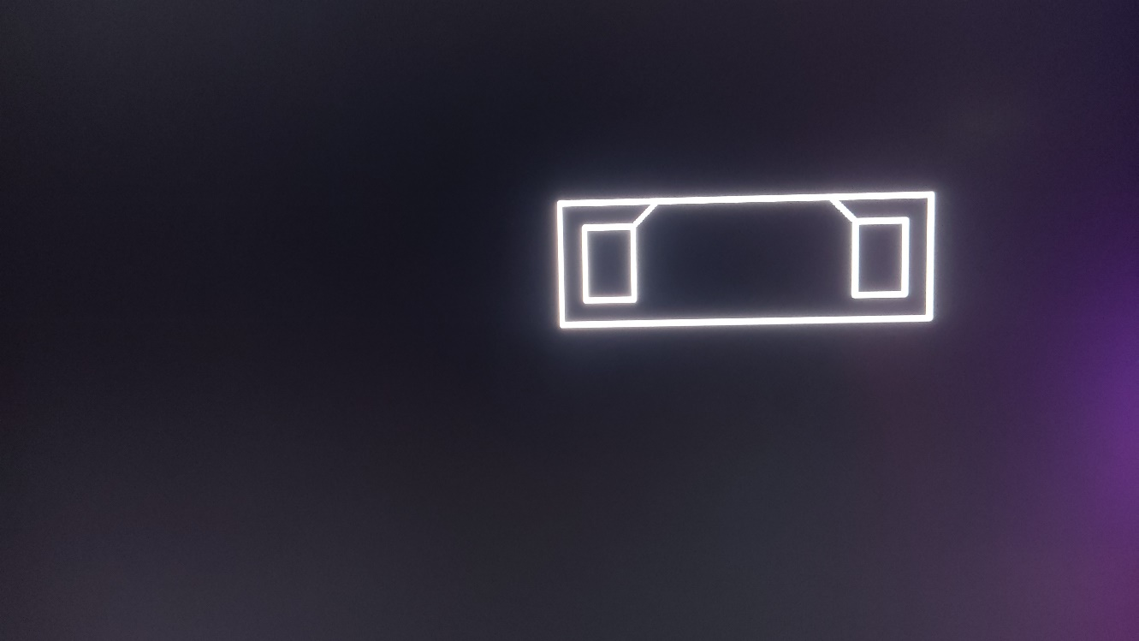

**Conclusion :**

Creating simple animations in C using graphics libraries provides an introduction to basic computer graphics concepts. In this example, the program uses the graphics.h library to draw and move a basic vehicle on the screen. The animation is achieved by clearing the screen in each iteration of the loop and redrawing the vehicle at a new position.

While this approach provides a basic understanding of animation in a graphical environment, it's important to note that graphics.h is specific to certain compilers and may not be available on all systems. Modern graphics programming often involves using more advanced libraries and frameworks, such as OpenGL, DirectX, or game development engines like Unity or Unreal Engine.

Additionally, the animation in this example is simple, and more complex animations often require sophisticated techniques, such as frame interpolation, sprite sheets, or skeletal animation. Aspiring graphics programmers may explore these advanced concepts and tools to create more intricate and visually appealing animations.